**T95plus**

**Product Specification**

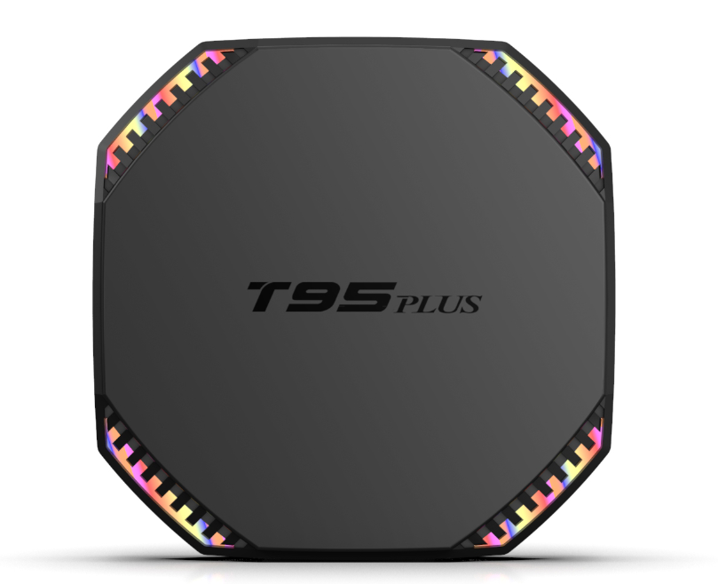

|  |  |  |
| --- | --- | --- |
| **Item** | | **Description** |
| **Packing** | **Product size** | 112*112*22 mm |
| **Packaged weight** | 0.4kg |
| **Loading for 20HQ** | 43.5*30*30.5 cm |
| **Product Color** | Black |
| **Hardware configuration** | **CPU** | RK3566 Quad core 64-bit Cortex-A55 Frequency:1.8GHZ |
| **GPU** | Mali-G52-2EE,Supports OpenGL ES 3.2/2.0/1.0 |
| **FLASH** | 32GB/64GB/128GB |
| **SDRAM** | 4GB/6GB/8GB |
| **WIFI/BT** | 2.4GHZ&5GHZ WIFI, Bluetooth 4.0 |
| **ETHERNET** | Standard 10/100/1000M RJ-45 |
| **HDMI** | HDMI 2.0 , 4Kx2K@60fps max resolution output |
| **USB host** | Universal Serial Bus 2.0 *1, High speed USB3.0 *1 |
| **SPDIF** | Audio Digital Interface |
| **Card reader** | TF card |
| **Power Supply** | **Power Supply** | DC 5V/2A |
| **CPU Engine** | **2D** | Hardware 2D graphics acceleration |
| **Video Decoder** | •H.265 HEVC/MVC Main10 Profile yuv420@L5.1 up to 4096x2304@60fps  •H.264 AVC/MVC Main10 Profile yuv400/yuv420/yuv422/@L5.1 up to 4096x2304@60fps  •VP9 Profile0/2 yuv420@L5.1 up to 4096x2304@60fps  •VP8 verision2,up to 1920x1088@60fps  •VC1 Simple Profile@low, medium, high levels, Main Profile@low, medium, high levels, Advanced Profile@level0~3,up to 1920x1088@60fps  •MPEG-4 Simple Profile@L0~6,Advanced Simple Profile@L0~5,up to 1920x1088@60fps  •H.263 Profile0,levels 10-70,up to 720x576@60fps |
| **Video Encoder** | •H.264/AVC BP/MP/HP@level4.2，up to 1920x1080@100fps  •H.265/HEVC MP@level4.1, up to 1920x1080@100fps (4096x4096@10fps with TILE)  •Support YUV/RGB video source with rotation and mirror |
| **JPEG decoder** | •Decoder size is from 48x48 to 65536x65536  •Support YUV400/YUV411/YUV420/YUV422/YUV440/YUV444  •Support 1920x1080@120fps  •Support MJPEG |
| **Software Specifications** | **OS** | Android 11.0 |
| **Preinstalled** | Preinstalled KDplayer, Youtube, Google play store, Chrome |
| **HDD file system** | FAT16/FAT32/NTFS |
| **Languages** | English/French/German/Spanish/Italian/ etc multilateral languages |