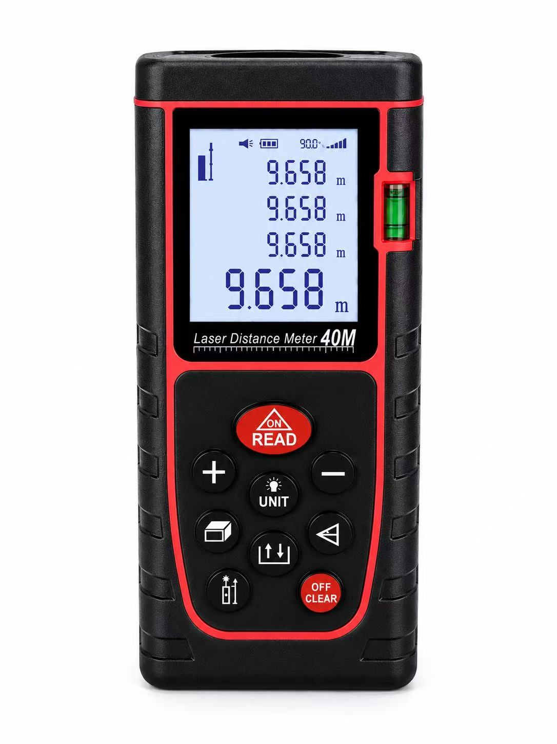

Regular models :OQ-40
Measuring accuracy: ± 3 mm
Measuring Range :0.03--40
Minimum display :1mm
Single measurement time: 0.1 to 4 seconds
Unit of measurement :m (meter) / ft (foot) / in (inch)
Laser Grade II :Gradell
Laser Type: 635nm
Laser power :< 1 mW
Continuous distance measurement :support
Area measurement: support
Volume Measurement :Support
Tick measurement :support
Area volume squared plus and minus measurement :support
Maximum and minimum measurements: support
Data storage up to: 20 groups
Measurement Benchmark Switching :Support
Display Lighting: Support
Beecher :Support
Battery Type AAA Battery 1.57x2
Battery life > 15,000 measurements
Dust / Water Splash: IP54
Operating temperature: 0 ° C - 40 ° C
Storage temperature :- 20 ° C - 60 ° C
Automatically turn off the laser for :15 seconds
Automatic shutdown for “45 seconds
Specifications :120 * 55 * 26mm

